NOMBRE: CRISTIAN RUEDA

TALLER SQL:

CONSULTA #1:

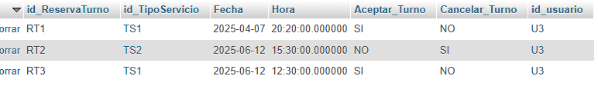

SELECT * FROM reserva_turno WHERE id_ReservaTurno = 'RT1';

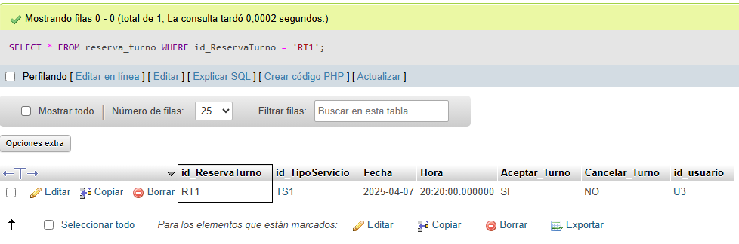

CONSULTA #2



[SELECT](http://localhost/phpmyadmin/url.php?url=https://dev.mysql.com/doc/refman/8.0/en/select.html) Fecha, Hora, Aceptar_Turno, Cancelar_Turno FROM reserva_turno WHERE Hora > '20:00';

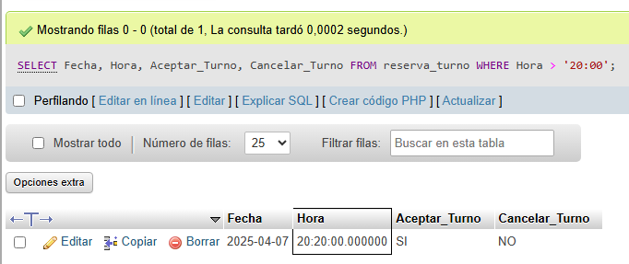

CONSULTA #3

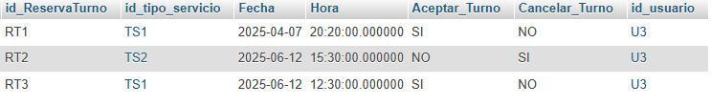

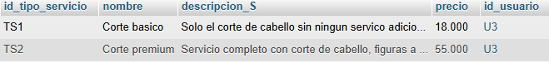

[SELECT](http://localhost/phpmyadmin/url.php?url=https://dev.mysql.com/doc/refman/8.0/en/select.html) r.Fecha, t.Nombre FROM reserva_turno r, tipo_servicio t WHERE r.id_tipo_servicio = t.id_tipo_servicio;

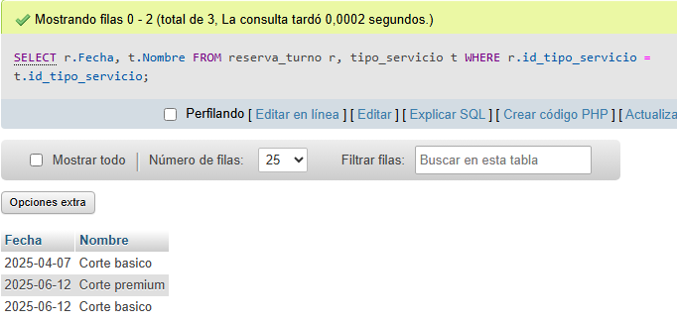

CONSULTA #4

[SELECT](http://localhost/phpmyadmin/url.php?url=https://dev.mysql.com/doc/refman/8.0/en/select.html) * FROM `compra` ORDER BY id_compra DESC;

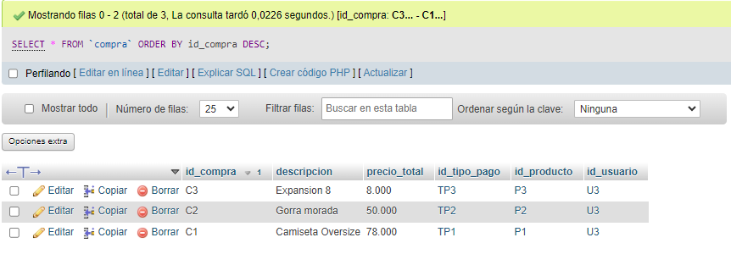

CONSULTA #5

[SELECT](http://localhost/phpmyadmin/url.php?url=https://dev.mysql.com/doc/refman/8.0/en/select.html) id_compra, id_usuario FROM compra GROUP BY id_compra;

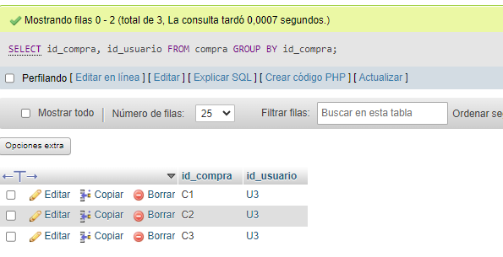

CONSULTA #6

[SELECT](http://localhost/phpmyadmin/url.php?url=https://dev.mysql.com/doc/refman/8.0/en/select.html) * FROM `usuarios` WHERE nombre_usuario = "Cristian" [OR](http://localhost/phpmyadmin/url.php?url=https://dev.mysql.com/doc/refman/8.0/en/logical-operators.html%23operator_or) nit = 1014481682;

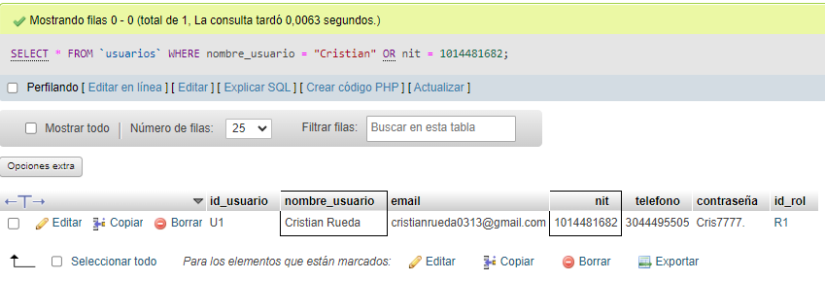

CONSULTA #7

[SELECT](http://localhost/phpmyadmin/url.php?url=https://dev.mysql.com/doc/refman/8.0/en/select.html) * FROM `usuarios` WHERE [NOT](http://localhost/phpmyadmin/url.php?url=https://dev.mysql.com/doc/refman/8.0/en/logical-operators.html%23operator_not) id_rol = 'R2';

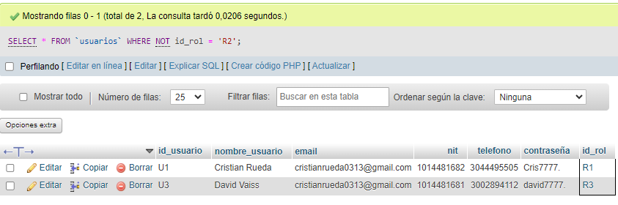

CONSULTA #8

[SELECT](http://localhost/phpmyadmin/url.php?url=https://dev.mysql.com/doc/refman/8.0/en/select.html) * FROM `reserva_turno` WHERE [NOT](http://localhost/phpmyadmin/url.php?url=https://dev.mysql.com/doc/refman/8.0/en/logical-operators.html%23operator_not) Aceptar_Turno = 'NO';

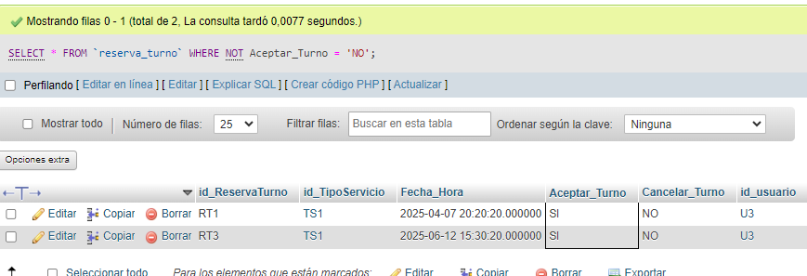

CONSULTA #9

[SELECT](http://localhost/phpmyadmin/url.php?url=https://dev.mysql.com/doc/refman/8.0/en/select.html) * FROM `reserva_turno` WHERE [NOT](http://localhost/phpmyadmin/url.php?url=https://dev.mysql.com/doc/refman/8.0/en/logical-operators.html%23operator_not) Aceptar_Turno = 'SI';

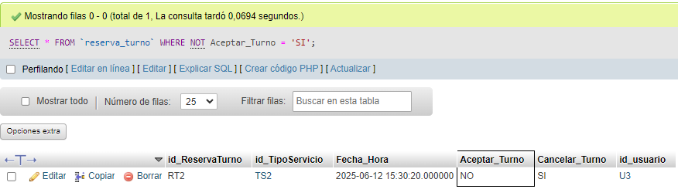

CONSULTA #10

[SELECT](http://localhost/phpmyadmin/url.php?url=https://dev.mysql.com/doc/refman/8.0/en/select.html) id_usuario, id_rol FROM usuarios GROUP BY id_usuario;

